**Puthuvasantham Children’s Home**

**Best Student 2017-2018**

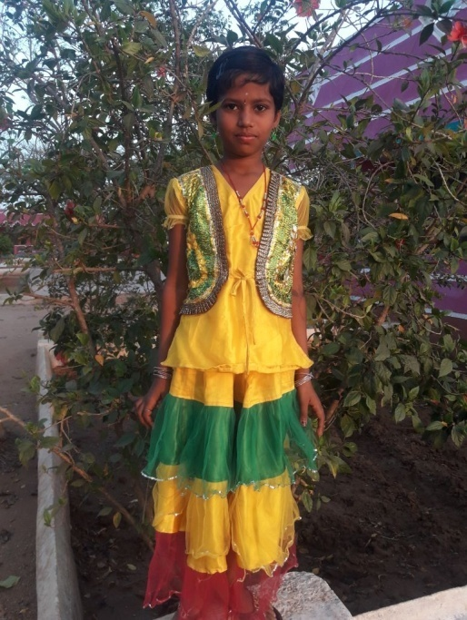

**Inbasri – II Std**

* Good at Dance
* Works well in job
* Hygienic
* Does well in studies
* Very active

**P. Nagajothi – V Std**

* Dance Well
* Does well in common work
* Excellent in Studies
* Very clean
* Good at drawing

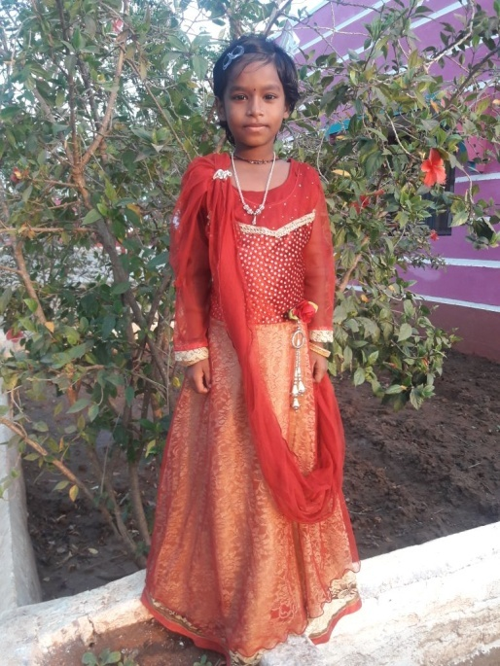

R. Hemalatha – V std

* Friendly in nature
* Very clean and tidy
* Excellent in her work
* Does well in her studies
* Punctual

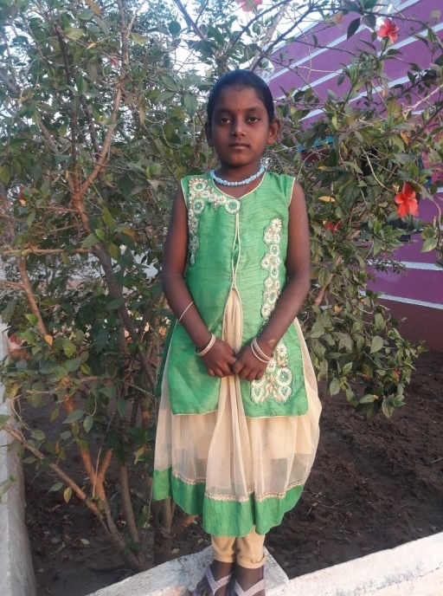

**Kalaiselvi – IV Std**

* Help others
* Hygenic
* Very active
* Excellent at Studies
* Does well in her work

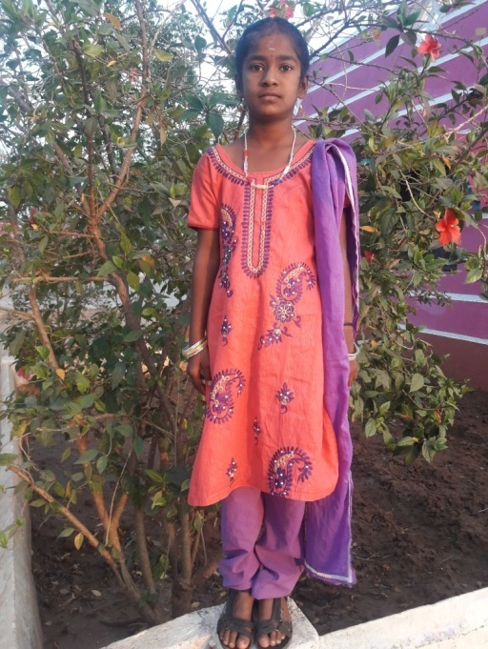

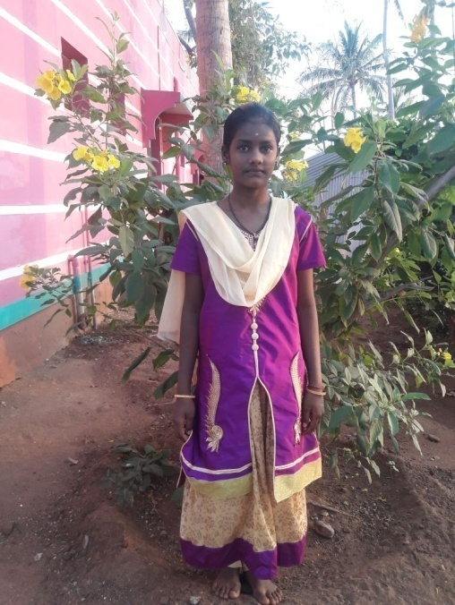

**Kalaiyarasi – VI Std**

* Draws well
* Very punctual
* Very responsible
* Very active
* Good at studies

1. **Yogeswari - VII Std**
   * + Good at singing
     + Excellent studies
     + Performs well in drawing
     + Commits to her work
     + very neat

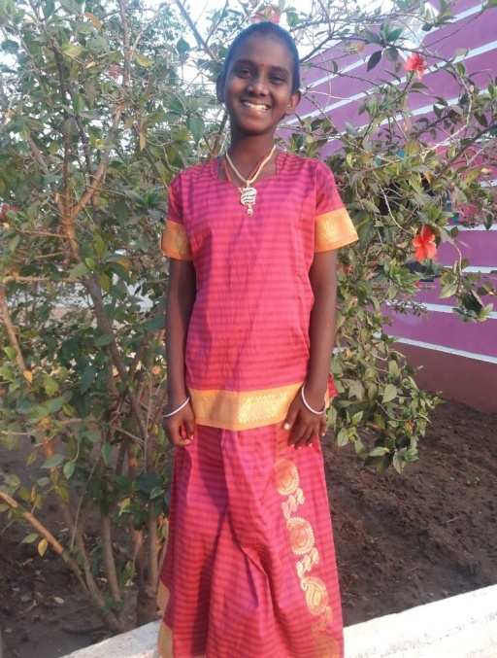

**R. Karthika- VII Std**

* + - Very good dancer
    - Good a t drawing
    - Good at studies
    - very responsible
    - Keeps herself clean

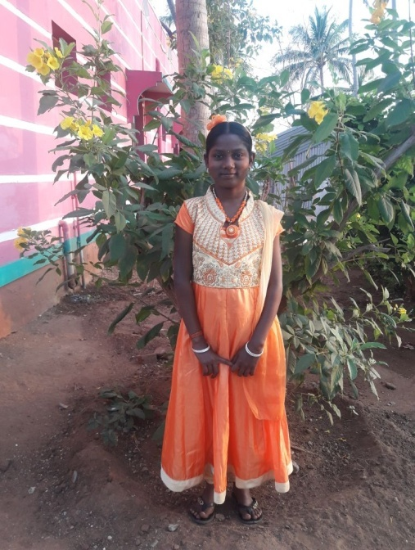

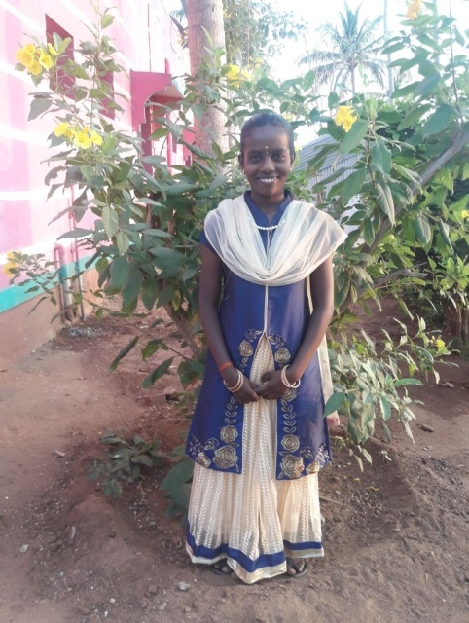

**B. Kaviya - VIII Std**

* + - Good at Drawing
    - Very good leader
    - Keeps herself clean
    - Excellent in Studies
    - Good at dancing

**R. Gayathri - IX Std**

* + - Very good studies
    - Excellent dancer
    - Helping habit
    - Neat and clean
    - Very good Leader

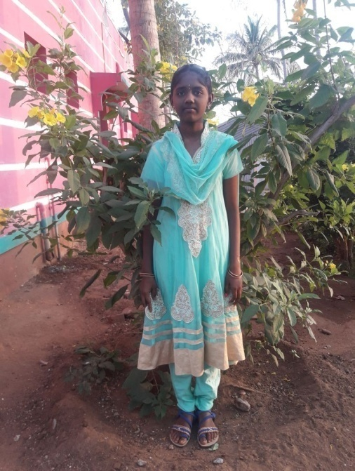

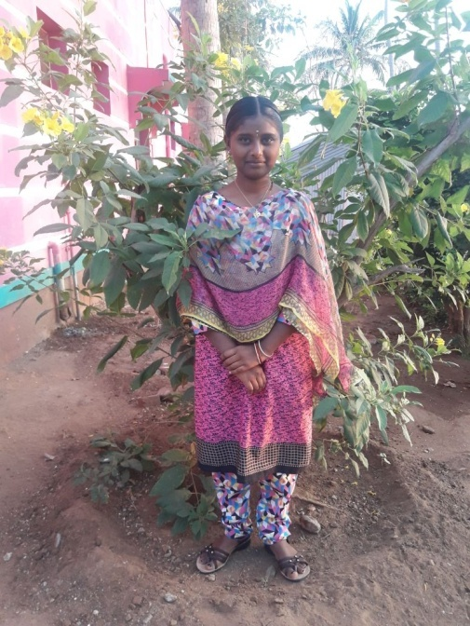

**S. Hemalatha - X Std**

* + - Keeps herself neat and tidy
    - Very good at studies
    - Very loving child
    - Exhibits leader sip quality
    - Very good dancer

Puthu Udayam Special School & Hostel

Best Student 2017-2018

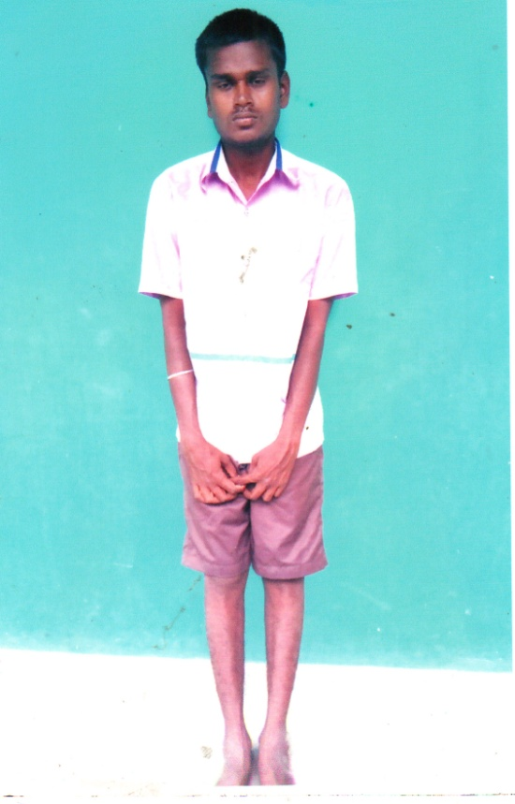

**S. Karthick**

* Very kind hearted
* Helps others
* Obedient
* Supports in maintaining the hostel

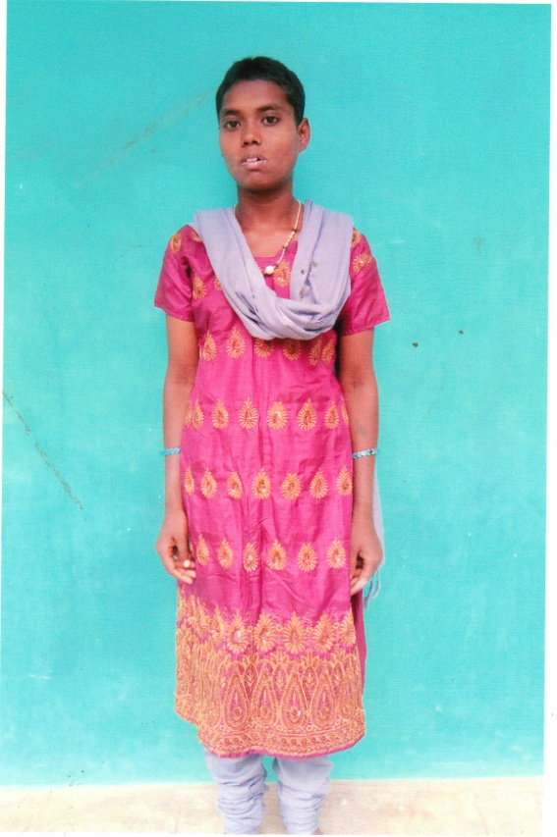

**S. Santhiya**

* Observes well
* Helps others
* Takes care of kids
* Obedient to the teachers

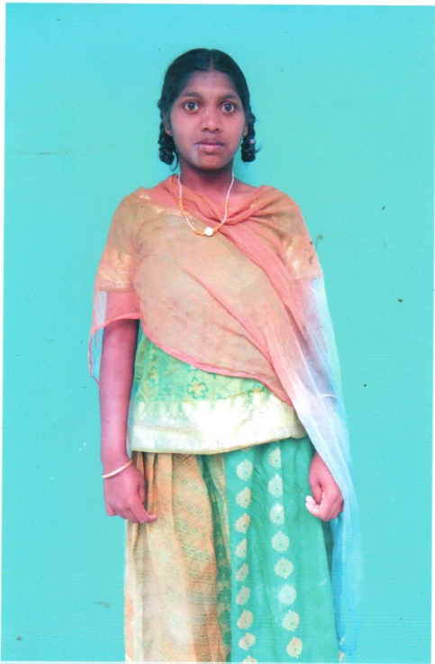

**M. Bhavatharani**

* Assists teachers in maintaining the records
* Loves and cares for the children
* Helps in washing the clothes of the children
* Very good dancer

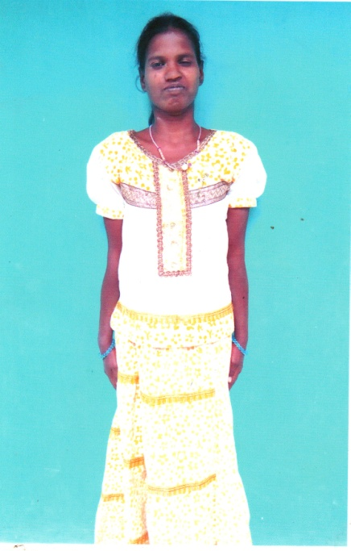

**S. Rama**

* Good at dancing
* Very responsible
* Holds responsibility in caring the children
* Helps wardens and teachers

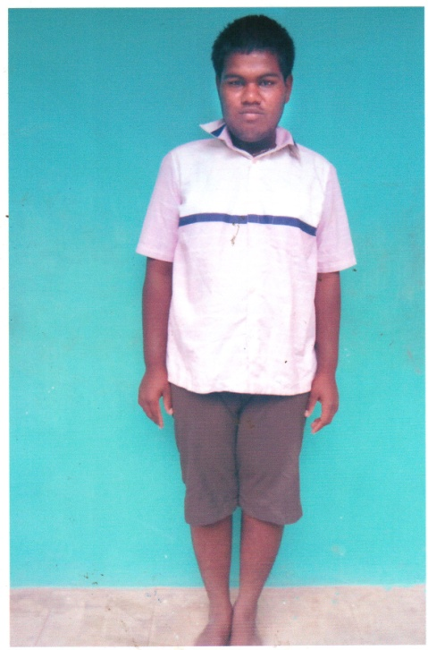

**M. Prakash**

* Cares for the children
* Helps in washing the clothes
* Obeys the teachers and wardens
* Interested in sports

Puthuirudayam Children’s Home

BEST STUDENT 2017 -2018

Puthupunal Children’s Home

BEST STUDENT 2017-2018

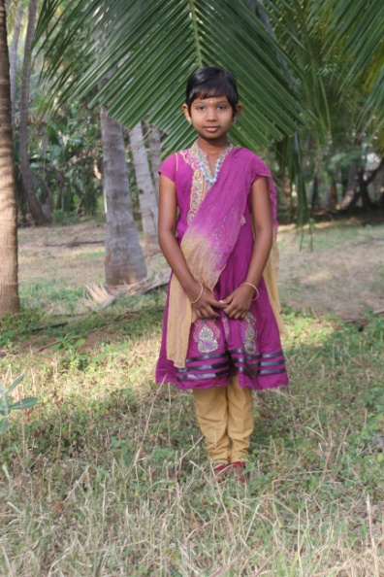

**V. Vimala – I Std**

* Very Quiet
* Good at Studies
* Obedient Girl
* Very calm in nature

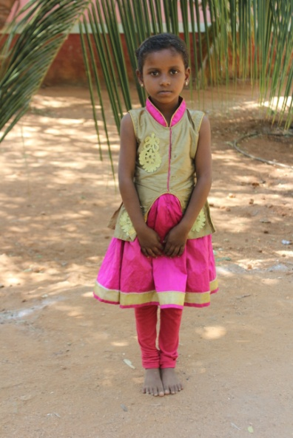

**D. Harishma – I Std**

* Very Calm in nature
* Excellent in Studies
* Obedient
* Very Talented

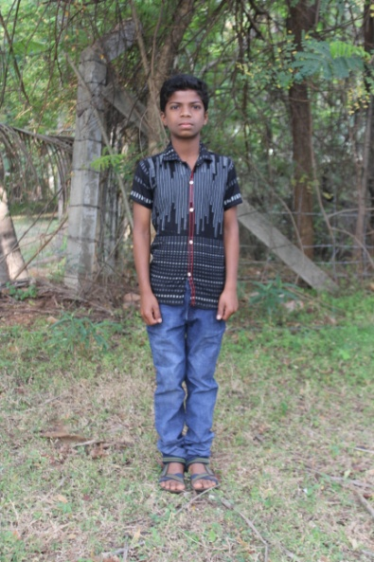

**S. Alex Pandian – V Std**

* Very Talented
* Responsible
* Obedient
* Enthusiastic

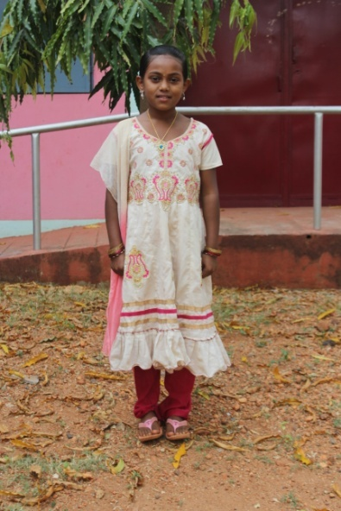

**T. Tharika Devi – V Std**

* Excellent speaker
* Responsible
* Obedient
* Calm and Quiet

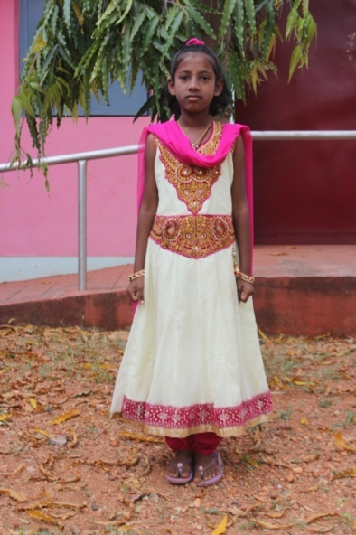

**S. Shereya Devi – V Std**

* Excellent in Studies
* Very good speaker
* Responsible
* Talented girl

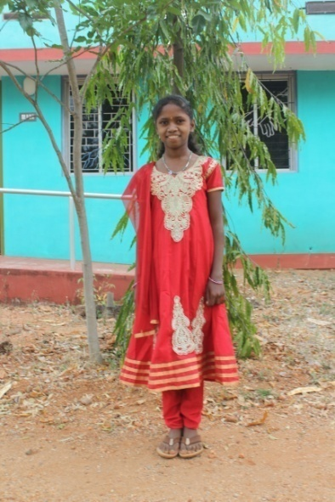

**N. Kaleeswari – VI Std**

* Very silent & Quiet in nature
* Very Talented
* Responsible
* Good at studies
* Obedient Girl

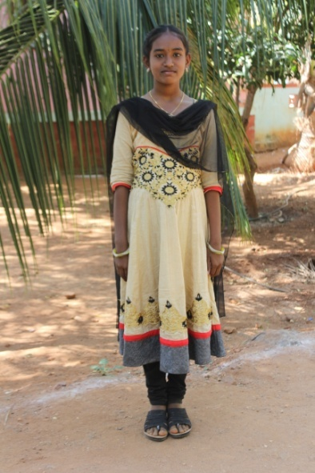

**K. Vidhya – VII Std**

* Good at studies
* Very silent in nature
* Disciplined
* Responsible

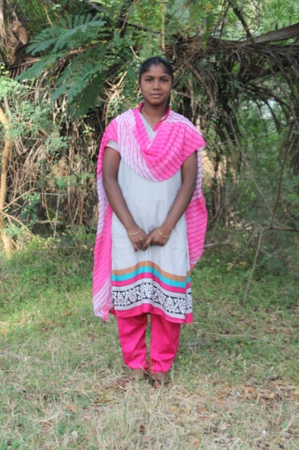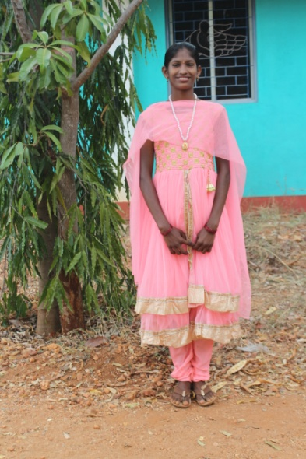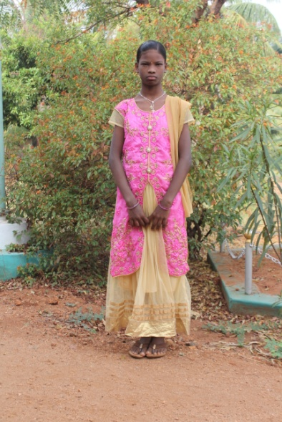

**Pandiswari – XII Std**

* Very loving in nature
* Responsible
* Very active and energetic
* Sacrificing
* Obedient
* Obedient Girl

**G. Vennila – IX Std**

* Very responsible
* Talented
* Enthusiastic
* Respectful

**G. Ganga Priya – VIII Std**

* Good at elocution
* Good at studies
* Respects others
* Talented girl